Here we specify each component and module in the ECU abstraction layer as well as the Low Layers Drivers. We start with the low layers to build such infrastructure for the higher layers as ECUAL and Application.

* **Low Layers**
* Microcontroller Abstraction Layer (MCAL):

1. 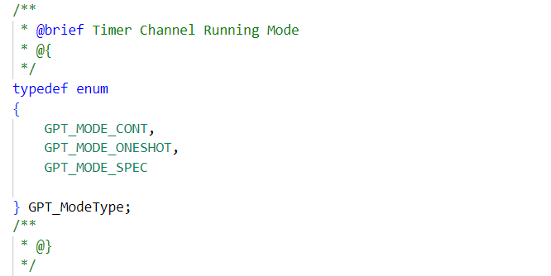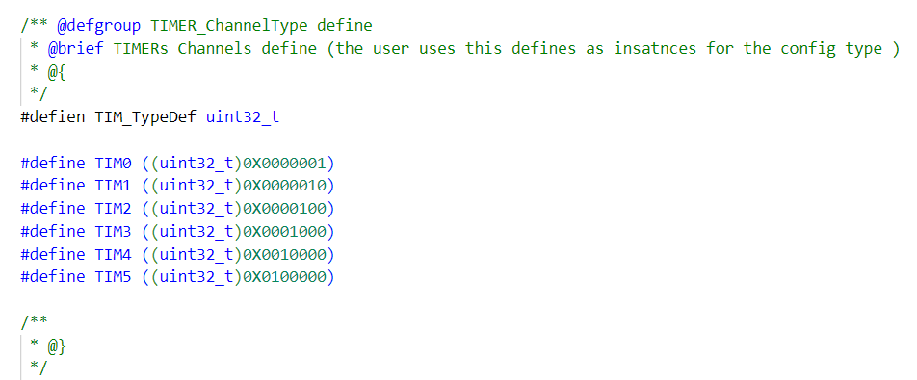Timer Module Driver  
     
   As specified in HRS this target micro controller is up to attach with number of sensors that will utilize the timer module for ti- ming management and synchronization of the communicati-on bus as it periodically transmit the tracing data on a CAN bus.  
     
   This Driver must provide APIs that utilize any of the hardware   
   timers inside the MCU and generate accurate time based event   
   triggering for specified number of times, API for providing the current counter of ticks as well as initialization functions.  
     
   API Type used for initialization the channels : _  
     
   API Type used for configure the modes: _  
   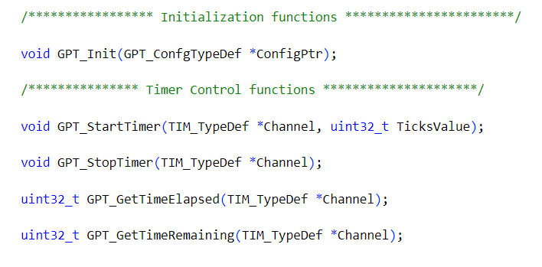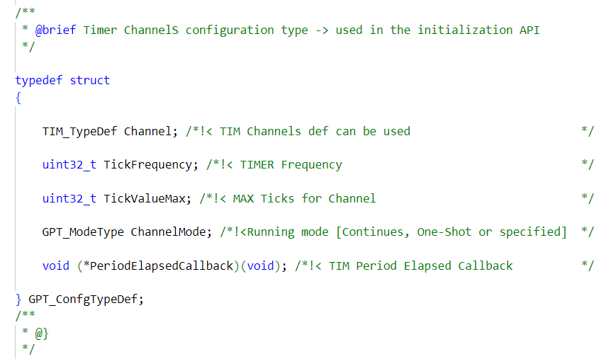API Type used for struct the configuration parameters: _  
     
   API functions used for initialization the driver and control operations : _
2. DIO Module Driver   
     
   Digital input/output will be used by the ECUAL layer to com-  
   munication with sensor and switches attached to the MCU.  
     
   It’s required to Provide full functional APIs to control the op-  
   eration of the GPIO Module from reading and writing data and also controlling external interrupts on the pins.  
   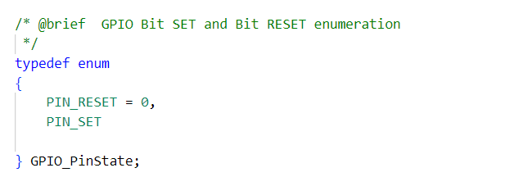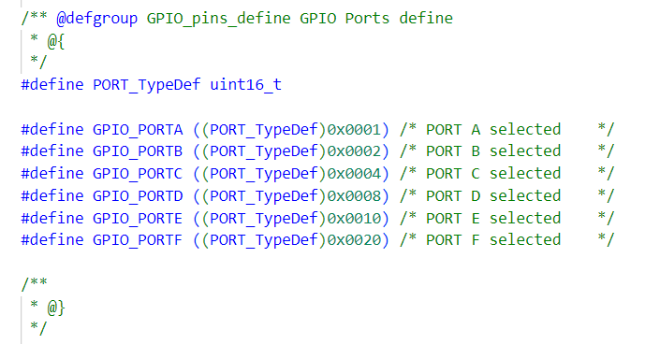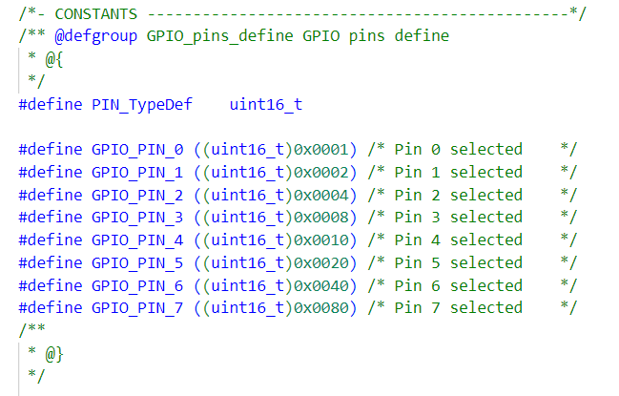API Type used for initialization the Pins :_  
   API Type used for specify the required PORT to control:_  
     
   API Type enum used to read and control the pins state:_  
   API Types used for the configuration parameters:_  
     
   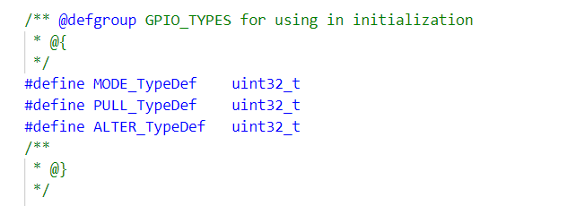  
     
   API Types used to configure the operation modes of the pins:_  
     
   Note : it’s up for the developer to define the required macros   
    for the bits positions according to the target used.   
     
   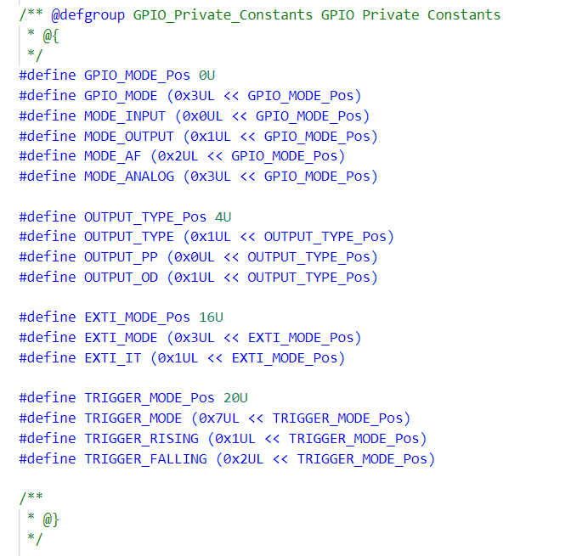  
     
     
   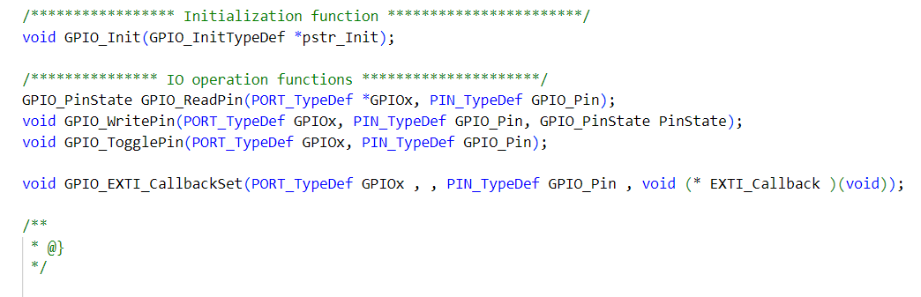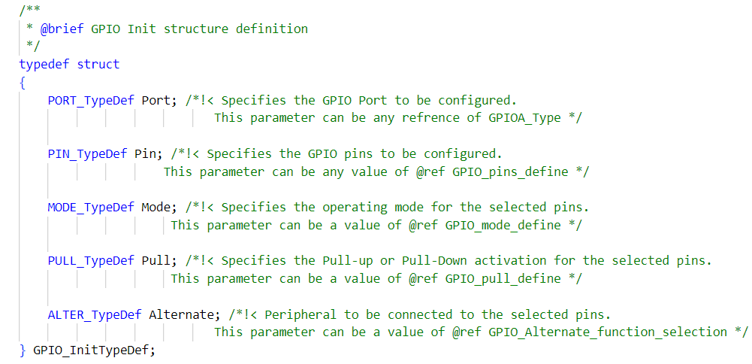API Type used to struct the configuration parameters and passing to the initializing API:_  
   API functions to initialize the DIO module and control operations:_
3. Input Capture Module   
     
   Dealing with sensors requires signals measurements, that’s why the IC Driver must provide such APIs functions to measure the   
   timing between rising and falling edges of the signal coming from the sensors, IC Driver utilize a timer unit on the selected target.  
     
   ECUAL layer depend on this driver to implement its components APIs. So that, it must be implemented accurately in order to evaluate such correct data from the sensors.  
     
   Here we illuminate the Module API types and functions ..  
   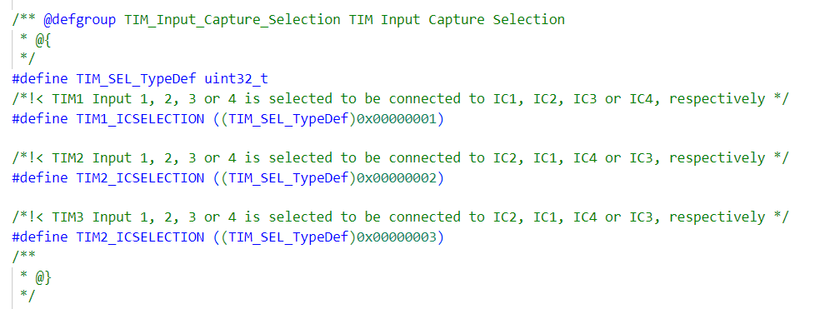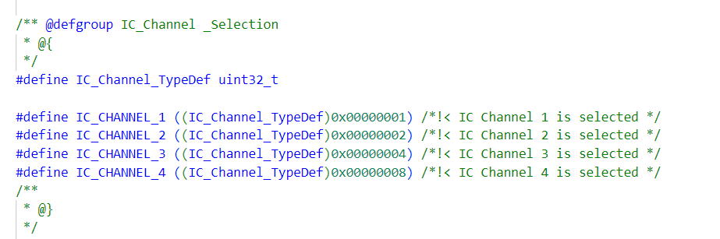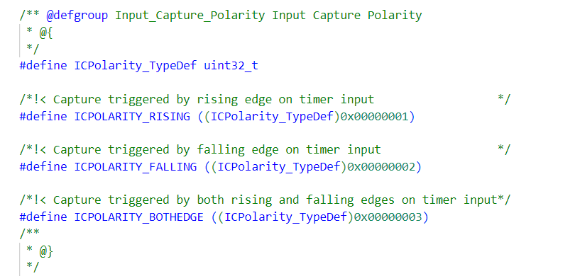API type to specify the channels to be configured:_  
     
     
   API type to select the utilized Timer to configure in IC mode :_  
     
      
   API type used to identify the Input Capture Polarity :_  
     
   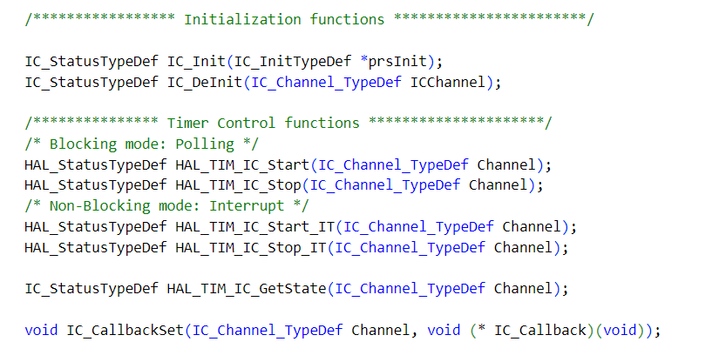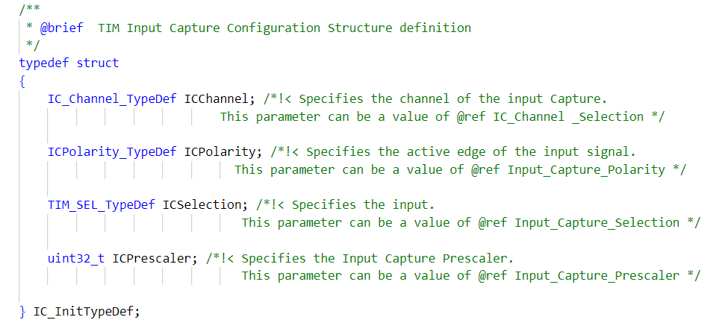API type to struct the configuration parameters of the module and pass it to the initialization API function.:_  
     
   API functions to initialize the IC Module and control its operation.